Digital Experience

https://www.learnexperiencecloud.com/
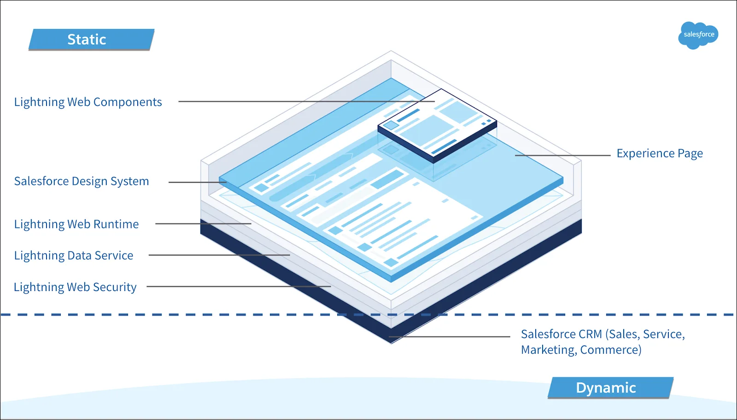
два типа сайтов
1. Aura sites
2. LWR Lightning Web Runtime - underlying technology that fuels the next generation of Experience Cloud sites. With a focus on performance and flexibility, LWR sites are faster and more developer-friendly than their Aura counterparts.

LWR сайт состоит из трех основных частей
- application that runs the site page
- set of plugins
- components that define the user interface
Быстрота за счет статичности — при публикации LWR сайта the framework and user interface layer are static (CDN)
The underlying data layer, made up of information from the Salesforce Platform, remains dynamic. Salesforce records, business processes, and other live data are updated in real time. The result is a website that is up to date with the most relevant information, but isn’t bogged down with slow load times.

A New Publishing Journey
Aura templates serve Lightning components dynamically. This means your site has to grab new data about components every time the page loads, slowing down the process. However, it also allows changes to your Lightning components to display without the need to republish your site.
Authentication Upgrade (/s в названии сайта)
Style? Check
Что можно сделать с Digital Exp
- Help Center & FAQ Portal - allow customers to get the answer immediately via forums, self-service portals, or knowledge bases
- Customer service and case escalation Portals - view content, update their profiles, and manage cases and claims. Your customers will receive direct access to data and processes to access information and complete any action.
- Salesforce Experience Cloud Partner Portal -
- Employee Community/Employee portals
- Microsites and Landing Pages
Лицензии
Customer Community
- no Campaign
- Dashboard
- Report
- Sending email
Customer Community Plus
- no Campaign
- Dashboard
-/+ Report
- Sending email
Partner Community
+ Campaign
+ Dashboard (read only)
+ Report

Benefits
- Personalized User Experiences
- Scalability and Flexibility
- Productivity - productivity tools, including task management, project management, and workflow automation, that help businesses work more efficiently and get more done in less time.
- Integration with Other Salesforce Products
- Enhanced Security including two-factor authentication, data encryption, and role-based access control, that help businesses keep their data secure and prevent unauthorized access.

Процесс создания состоит из следующих этапов
1. Setup → Digital Experiences → Enable Digital Experiences
2 Settings
3 Digital Experiences → All Sites → New
4 Administration
5 Builder
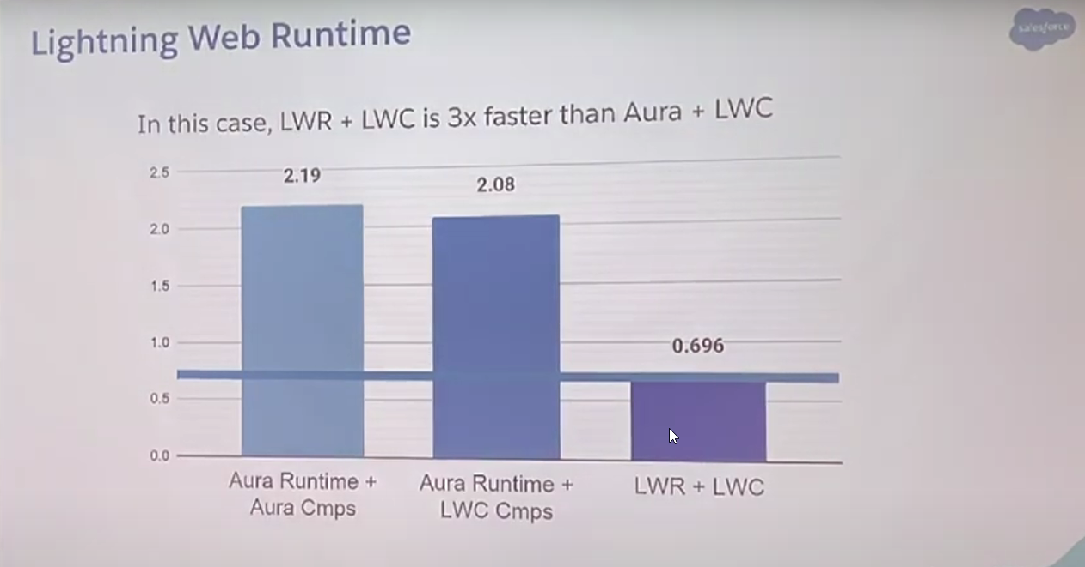

Digital Experience on Scratch Org
https://github.com/mroutt/PortfolioSite
project-scratch-def.json
{
"orgName": "Demo company",
"edition": "Developer",
"features": ["Communities", "Sites", "EnableSetPasswordInApi"],
"settings": {
"lightningExperienceSettings": {
"enableS1DesktopEnabled": true
},
"mobileSettings": {
"enableS1EncryptedStoragePref2": false
},
"communitiesSettings": {
"enableNetworksEnabled": true
},
"experienceBundleSettings": {
"enableExperienceBundleMetadata": true
}

}
}
sf project retrieve preview – просмотреть файлы с инстанса
sf project retrieve start – залить файлы с инстанс в проект
sf project deploy start – залить файлы проекта в инстанс

Local Dev
https://developer.salesforce.com/docs/platform/lwc/guide/get-started-test-components.html
Step 1
sf plugins install @salesforce/plugin-lightning-dev
Step 2
config/project-scratch-def.json
"lightningExperienceSettings": {
"enableLightningPreviewPref": true
},
Step 3
on LWR Builder->General->Public Access
Step 4
run Local Dev for LWR
sf lightning dev site --target-org DeployWithDev --name PortfolioSite

Visual Studio код в гите (ветка master) https://github.com/alexp1402/LWR-community-Portfolio-site/tree/master
1 create DevHub
2 ctrl+shift+p command Create Default Scratch Org
3 sf org open
4 активировать портал
5 опубликовать портал
6 для работы с локальным сервером сделать портал публичным Builder→ Settings→ Public Access
To give guest users access to the site's APIs, enable “Allow guest users to access public APIs” in Workspaces > Administration > Preferences

